PANCAR WAHYU SETIABI

H1D024018

SHIF D

1. Merubah nama field/kolom

MariaDB [orderentry]> desc products;

+------------+--------------+------+-----+---------+-------+

| Field | Type | Null | Key | Default | Extra |

+------------+--------------+------+-----+---------+-------+

| prod_id | varchar(10) | NO | PRI | NULL | |

| vend_id | char(4) | NO | MUL | NULL | |

| prod_name | varchar(25) | NO | | NULL | |

| prod_price | int(11) | NO | | NULL | |

| prod_desc | varchar(255) | NO | | NULL | |

+------------+--------------+------+-----+---------+-------+

5 rows in set (0.025 sec)

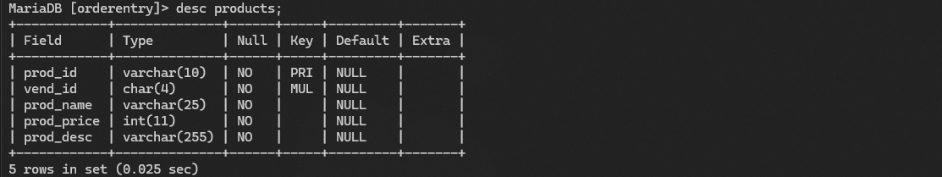

MariaDB [orderentry]> alter table products change prod_desc desc_prod varchar (255) not null;

Query OK, 0 rows affected (0.012 sec)

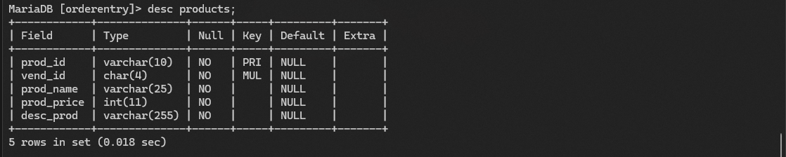Records: 0 Duplicates: 0 Warnings: 0

1. Perubahan terhadap tipe data

MariaDB [orderentry]> desc products;

+------------+--------------+------+-----+---------+-------+

| Field | Type | Null | Key | Default | Extra |

+------------+--------------+------+-----+---------+-------+

| prod_id | varchar(10) | NO | PRI | NULL | |

| vend_id | char(4) | NO | MUL | NULL | |

| prod_name | varchar(25) | NO | | NULL | |

| prod_price | int(11) | NO | | NULL | |

| desc_prod | varchar(255) | NO | | NULL | |

+------------+--------------+------+-----+---------+-------+

5 rows in set (0.018 sec)

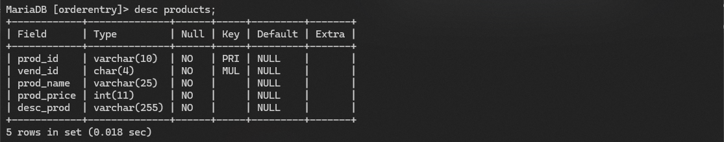

MariaDB [orderentry]> alter table products modify desc_prod char (25) not null;

Query OK, 0 rows affected (0.067 sec)

Records: 0 Duplicates: 0 Warnings: 0

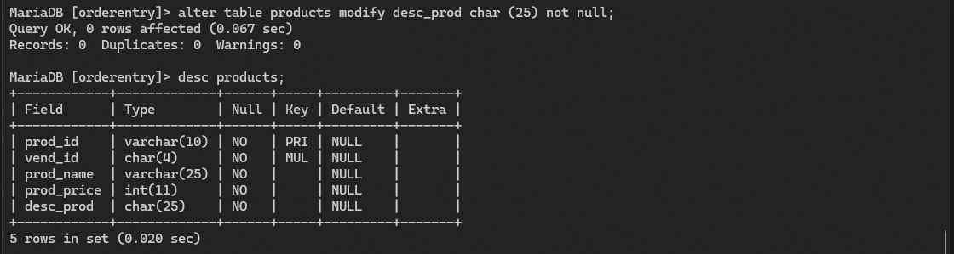

1. Penambahan field/kolom

MariaDB [orderentry]> desc products;

+------------+--------------+------+-----+---------+-------+

| Field | Type | Null | Key | Default | Extra |

+------------+--------------+------+-----+---------+-------+

| prod_id | varchar(10) | NO | PRI | NULL | |

| vend_id | char(4) | NO | MUL | NULL | |

| prod_name | varchar(25) | NO | | NULL | |

| prod_price | int(11) | NO | | NULL | |

| desc_prod | varchar(255) | NO | | NULL | |

+------------+--------------+------+-----+---------+-------+

5 rows in set (0.023 sec)

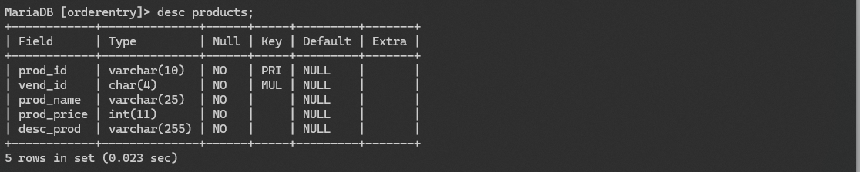

alter table products add quality_prod varchar (200) not null;

Query OK, 0 rows affected (0.005 sec)

Records: 0 Duplicates: 0 Warnings: 0

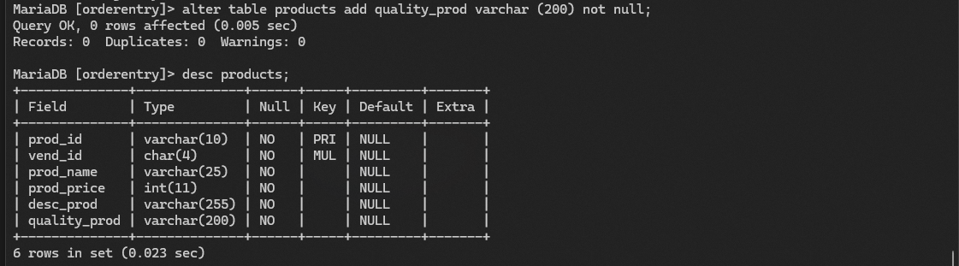

1. Penghapusan field

MariaDB [orderentry]> desc products;

+--------------+--------------+------+-----+---------+-------+

| Field | Type | Null | Key | Default | Extra |

+--------------+--------------+------+-----+---------+-------+

| prod_id | varchar(10) | NO | PRI | NULL | |

| vend_id | char(4) | NO | MUL | NULL | |

| prod_name | varchar(25) | NO | | NULL | |

| prod_price | int(11) | NO | | NULL | |

| desc_prod | varchar(255) | NO | | NULL | |

| quality_prod | varchar(200) | NO | | NULL | |

+--------------+--------------+------+-----+---------+-------+

6 rows in set (0.023 sec)

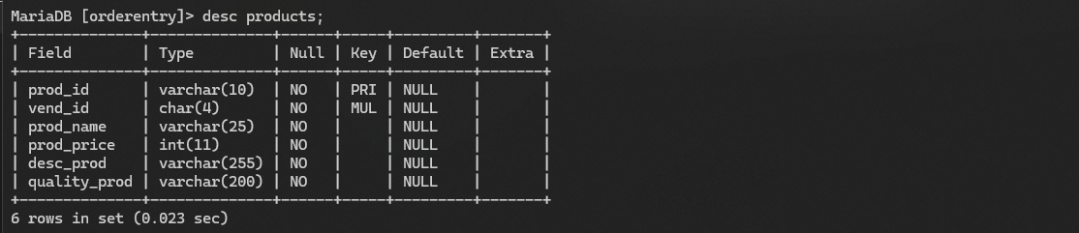

MariaDB [orderentry]> alter table products drop column quality_prod;

Query OK, 0 rows affected (0.007 sec)

Records: 0 Duplicates: 0 Warnings: 0

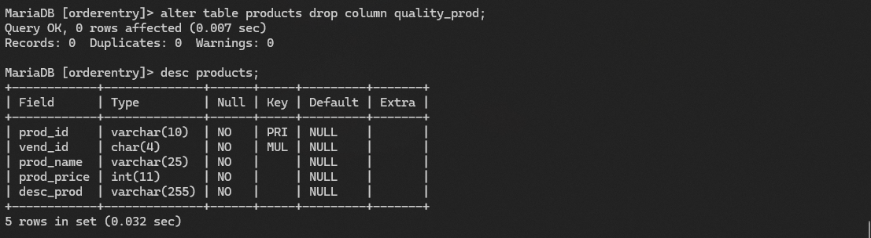

1. Pembuatan table baru

MariaDB [orderentry]> show tables;

+----------------------+

| Tables_in_orderentry |

+----------------------+

| customers |

| orderitems |

| orders |

| productnotes |

| products |

| vendors |

+----------------------+

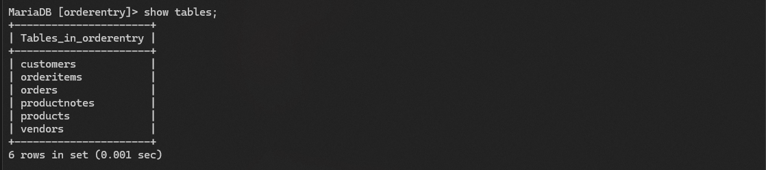6 rows in set (0.001 sec)

MariaDB [orderentry]> CREATE TABLE contact_customer(

-> id_cust varchar(5) NOT NULL PRIMARY KEY,

-> hp1 VARCHAR(20) NOT NULL,

-> hp2 VARCHAR(20));

Query OK, 0 rows affected (0.012 sec)

